COMMONWEALTH OF KENTUCKY JUDICIAL CONDUCT COMMISSION
IN RE THE MATTER OF:
RONNIE C. DORTCH, CIRCUIT COURT JUDGE
38TH JUDICIAL CIRCUIT

PUBLIC REPRIMAND
Ronnie C. Dortch served as Circuit Court Judge for Kentucky's 38th Judicial Circuit consisting of Butler, Edmondson, Hancock and Ohio Counties from 1992 until his retirement on January 6, 2017. Prior to his retirement, the Commission commenced preliminary proceedings as provided in SCR 4.170. Therefore, the Commission retains jurisdiction over this matter pursuant to SCR 4.025. Judge Dortch has waived formal proceedings and has agreed to the disposition made in this Order.
The Commission initiated a preliminary investigation upon receipt of information that, from 2014 to 2015, Judge Dortch engaged in a sexual relationship with a woman who was indicted in a felony criminal case in which he was presiding. The information further indicated that Judge Dortch had ex-parte communications with the woman on several occasions in which he discussed her pending criminal case.
In the Commission's view, engaging in a sexual relationship with a party by the judge presiding in the case would be grounds for removal from office. The conduct of the judge shocks the conscience of the Commission. The Commission concludes that Judge Dortch's conduct violated SCR 4.020(1)(b)(i) and that he engaged in misconduct in office. The Commission further concludes that Judge Dortch violated SCR 4.300 and the relevant
portions of the following Canons of the Code of Judicial Conduct:
Canon 1 which requires judges to maintain high standards of conduct and uphold the integrity and independence of the Judiciary.
1
Canon 2A which requires judges to respect and comply with the law and act at all times in a manner that promotes public confidence in the integrity and impartiality of the judiciary.
Canon 3B(7) which requires judges to give every person who has a legal interest in a proceeding, or that person's lawyer, the right to be heard according to law and prohibits judges from engaging in ex parte communications except in certain circumstances.
Canon 3E(1) which requires a judge to disqualify himself or herself in a proceeding in which the judge's impartiality might reasonably be questioned.
Because Judge Dortch has retired, a public reprimand is the most severe sanction the Commission can impose. Based upon the foregoing conduct, Judge Dortch is hereby publicly reprimanded.
Date: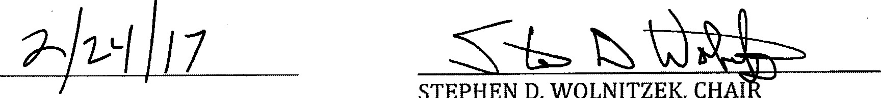
STEPHEN
D.
WOLNITZEK,
Agreed to:
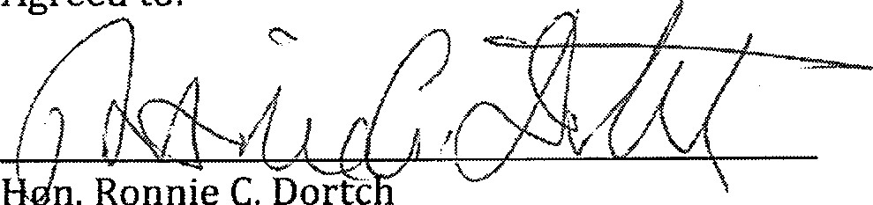
n.
Ronnie
C.
Dortc
Judge Jeff S. Taylor recused from any consideration of this matter.
2

