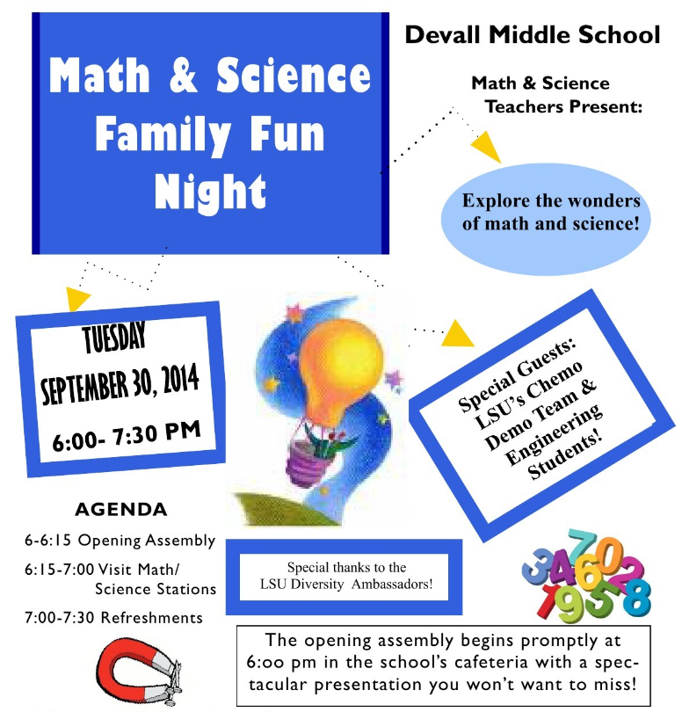- - - - - - - - - - - - - - - - - - - - - - - - - - - - - - - - - - - - - - - - - - - - - - - - - - - - - - - - - - - - - - - - - - - - - - - - - - - - - - - - - - - - - - - - - - - -

Morgantown Elementary School
270.asd
270.526.3361
Attend the Groovy MES Book Fair for Family Night with games and prizes
Explore the
Family Fun Night: English/Language Arts &
Social Studies
Tuesday,
March 1st
5:00-7:00
Games, Activities, Food, Fun
5:00-5:25 Meal
5:25-5:40 Opening
5:40-6:50 Visit Stations
6:50-7:00 Door Prizes
PLEASE RETURN THIS FORM TO YOUR CLASSROOM TEACHER BY Thursday, February 25th 2016. (One per family only)
☐ The __________________ family intends to come to the Family Fun Night on March 1st, 2016 5:00-7:00
Name and grade of students attending: ___________________________ _____________________________
____________________________ ___________________________ _______________________________
Number of adults attending: ____________
☐ Unfortunately, the ___________________ family is unable to attend.

