A New Fastpitch Softball League for Girls Ages 9-12

SIGN UP TODAY!

2018
Butler County Jr. Pro Softball

Ages 9-12

April-June
2018
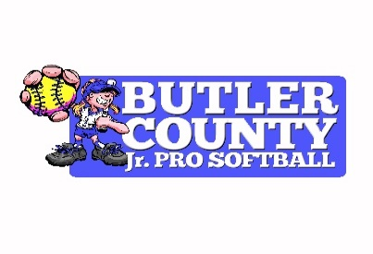
Questions? Contact BC Jr. Pro Softball Coordinator Katie Gary at 270-999-3195 or by email at katie.gary@ohio.kyschools.us or BCHS Head Softball Coach John Embry at 270-526-7945 or by email at john.embry@butler.kyschools.us.

OFFICIAL SIGN-UP FORM

The Butler County High School Bears softball team is in the process of starting a new fastpitch softball league for girls ages 9-12.
The league - Butler County Jr. Pro Softball - will be organized through the Butler County Board of Education with a Jr. Pro Coordinator managing the league.
All players will be covered under the school district's insurance policy. Age eligibility will be determined by a player's age on January 1, 2018.
The league will run April - June 2018 for games with player evaluation and a draft to be held in March. Specific dates will be announced at a later date. The entry fee will be $65 per player and it will cover a uniform jersey, trophies/awards, umpire fees, field maintenance, equipment, and other expenses associated with the operation of the league. Players will be responsible for black pants, belt, black socks, and a helmet.
League games will be played at the Charles Black City Park softball field with and end-of-season tournament at the high school softball complex.
Player evaluation and draft day is Saturday, March 3, from 12 to 3 at the BCHS Softball Field.

---------------------------------------------------------------------------

Player's Name: _________________________________________________

Address: ________________________________________________________

___________________________________________________________________

Age: _______________ (as of January 1, 2018)

Do you have any experience pitching? ______________________

Contact Phone #: ______________________________________________

Parent's Signature: ____________________________________________

As a parent would you be willing to help the league in any of the following ways (check each one):

______ Head Coach _____ Assistant Coach _______ Umpire

_____Serve on a Committee (field maintenance, opening day, fundraising, etc.)

--All adult volunteers working directly with children will be will be required to complete a background check through the Butler County Board of Education.

